Capacity Management

WHY:
Every application makes its own demands on the IT environment. Some are unavoidable, such as the continuing spread of applications for enterprise resource planning (ERP), supply chain management or human-resources management. Also new applications are emerging (e.g., those employing multimedia content) that will impact IT with their heavy demands for bandwidth. Finally, additional applications are required to support the growing IT infrastructures of organisations (eg. remote storage of back-up data, for example).

Failure to consider these issues will lead to under and negative effects on the business, as the capacity of the IT Environment simply does not match the requirements of the business.

GOAL:
The Capacity Management process understands the business requirements (the required Service Delivery), the organisation's operation (the current Service Delivery) and the IT Infrastructure (the means of Service Delivery). It ensures that all the current and future Capacity and performance aspects of the business requirements are provided cost-effectively.

ACTIVITIES:
- Business Capacity Management: This sub-process is responsible for ensuring that the future business requirements for IT Services are considered, planned and implemented in a timely fashion. This can be achieved by using the existing data on the current resource utilisation by the various services to trend, forecast or model the future requirements. These future requirements come from business plans outlining new services, improvements and growth in existing services, development plans etc.
- Service Capacity Management: The focus of this sub-process is the management of the performance of the live, operational IT Services used by the Customers. It is responsible for ensuring that the performance of all services, as detailed in the targets in the SLAs and SLRs, is monitored and measured, and that the collected data is recorded, analysed and reported. As necessary, action is taken to ensure that the performance of the services meets the business requirements. This is performed by staff with knowledge of all the areas of technology used in the delivery of end-to-end service, and often involves seeking advice from the specialists involved in Resource Capacity Management.
- Resource Capacity Management: The focus in this sub-process is the management of the individual components of the IT Infrastructure. It is responsible for ensuring that all components within the IT Infrastructure that have finite resource are monitored and measured, and that the collected data is recorded, analysed and reported. As necessary, action must be taken to manage the available resource to ensure that the IT Services that it supports meet the business requirements. In carrying out this work, the Capacity Management process is assisted by individuals with specialist knowledge in the particular areas of technology.

BENEFITS:
✓ Increased efficiency and cost savings
    - Deferred expenditure
    - Economic provision of services
    - Planned buying
✓ Reduced risk
✓ More confidence in forecasts

Iterative Activities (Performance Management)

      - Analysis
      - Tuning
      - Implementation
      - Monitoring

Other Activities
- Demand management
- Application sizing
- Modelling
- Storage of Cap Data
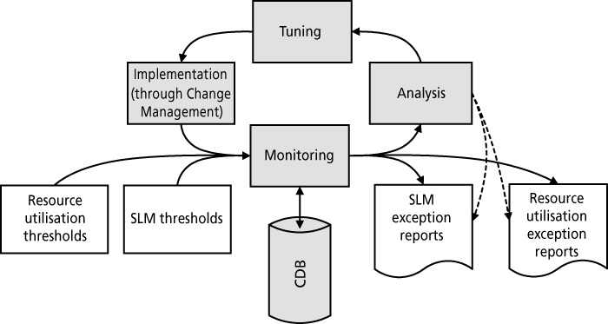
- Capacity Plan development and maintenance.

RESULTS:
- Capacity-plan(s)
- Capacity Management Data Base (CDB)
- Baselines and profiles
- Threshold and alarms
- SLA & SLR recommendations
- Capacity Reports
- Costing and Charging recommendations
- Proactive changes and service improvements
- Revised operational schedule
- Effectiveness reviews
- Audit reports

COST:
The costs associated with establishing a Capacity Management process include:
  - Monitoring tools (for performance and utilisation) covering hardware, operating system and application Capacity. These tools should be capable of monitoring and collecting data from all required host, network and client environments
  - CDB (Capacity Database) for holding a historic record of all service, technical, utilisation, financial and business data
  - Modelling tools for performing simulation modelling and statistical analysis
  - Graphical and textual reporting tools (often web-enabled)
- Project management - implementation of Capacity Management should be treated as a project
- Staff costs - recruitment, training and consultancy costs associated with the set-up of the Capacity Management process
- Accommodation - provision of an adequate working environment and facilities, which may be distributed.
The costs associated with maintaining a Capacity Management include:
- Annual maintenance and required upgrades of all hardware and software tools
- On-going staff costs including salaries, further training and ad-hoc consultancy
- Recurring accommodation costs such as leasing, rental and energy costs.

